Lab 06

Implementation of Timer using 8051

Objective:

* To Learn how to create exact delays using timers in 8051 micro-controller

Components needed for this lab:

* Keil µVision IDE
* Proteus Software
* 8051 Micro-controller

8051 Micro-controller:

* 8051 have 40 pins dedicated for various functions such as I/O, -RD, -WR, address, data, and interrupts.
* The 8051 has an on-chip oscillator but requires an external clock to run it. A quartz crystal oscillator is connected to inputs XTAL1 (pin19) and XTAL2 (pin18). The quartz crystal oscillator also needs two capacitors of 30 pF value

Tasks

1: Use timer to Generate a delay of 15ms

***#include* *<reg51.h>***

***#include* *<stdio.h>***

**sbit pin = P3^0;**

**void startTimer0()**

**{**

**TR0 = 1;**

**}**

**void startTimer()**

**{**

**TMOD = 0x01;**

**IE = 0x82;**

**}**

**void timer() interrupt 1**

**{**

**TH0 = 0xC5;**

**TL0 = 0x67;**

**}**

**void main(void)**

**{**

**startTimer0();**

**startTimer();**

**while (TF0==0);**

**pin=~pin;**

**}**

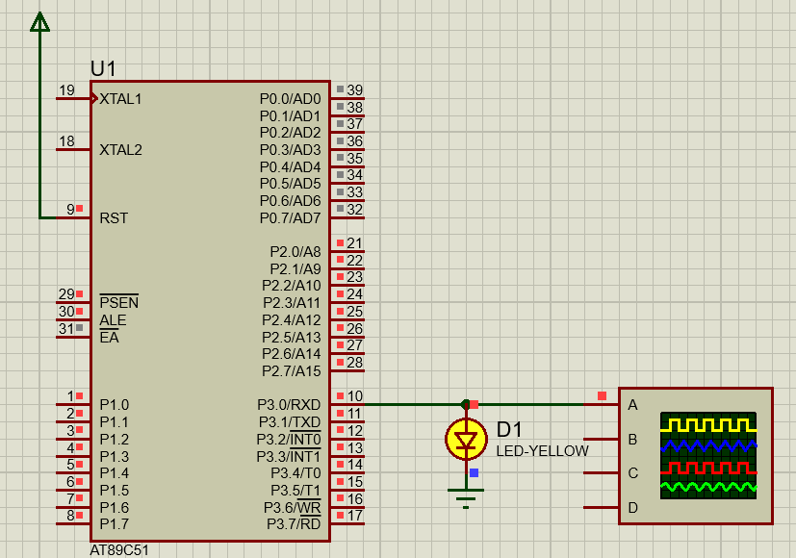

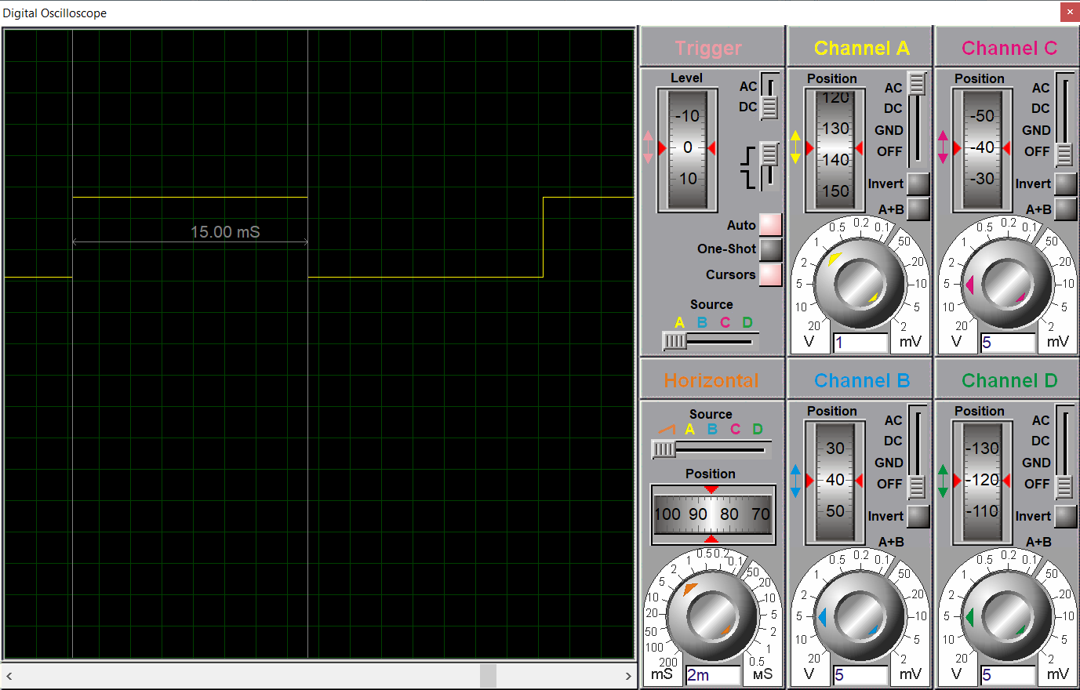

___________________________________________________________________________________________________________

2: Use timer to Generate a delay of 50ms

***#include* *<reg51.h>***

***#include* *<stdio.h>***

**sbit pin = P3^0;**

**void startTimer0()**

**{**

**TR0 = 1;**

**}**

**void startTimer()**

**{**

**TMOD = 0x01;**

**IE = 0x82;**

**}**

**void timer() interrupt 1**

**{**

**TH0 = 0x3A;**

**TL0 = 0x98;**

**}**

**void main(void)**

**{**

**startTimer0();**

**startTimer();**

**while (TF0==0);**

**pin=~pin;**

**}**



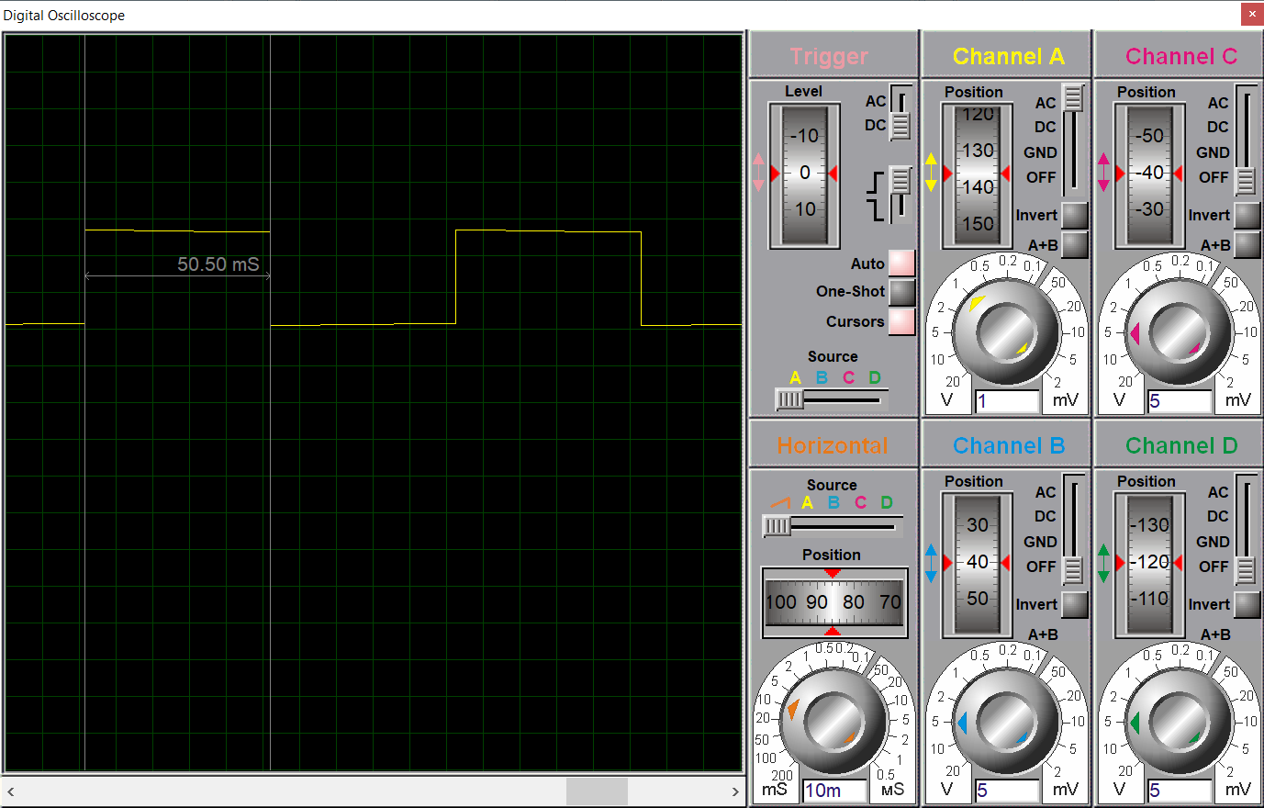

___________________________________________________________________________________________________________

3: Use timer to Generate a delay of 200ms

***#include* *<reg51.h>***

***#include* *<stdio.h>***

**sbit pin = P3^0;**

**void delay(unsigned int x)**

**{**

**int i=0, j=0;**

**for(i=0; i<1000; i++)**

**{**

**for(j=0; j<x; j++)**

**{**

**}**

**}**

**}**

**int main()**

**{**

**unsigned int x = 0;**

**while(1){**

**delay(16);**

**pin = ~pin;**

**}**

**}**



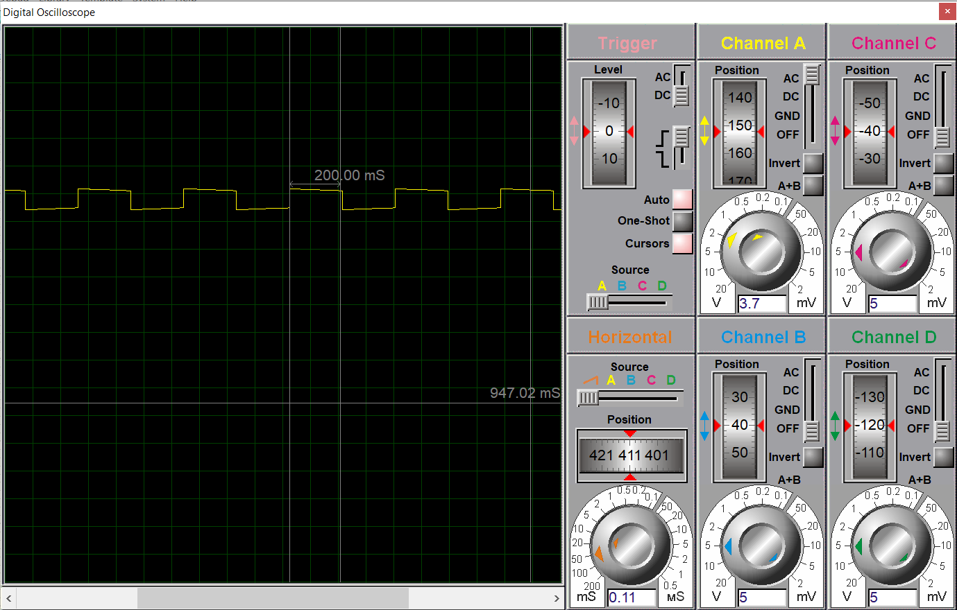

________________________________________________________________________________________________________

4: Use timer to Generate a delay of 200µs

***#include* *<reg51.h>***

***#include* *<stdio.h>***

**sbit pin = P3^0;**

**void startTimer0()**

**{**

**TR0 = 1;**

**}**

**void startTimer()**

**{**

**TMOD = 0x01;**

**IE = 0x82;**

**}**

**void timer() interrupt 1**

**{**

**TH0 = 0xFF;**

**TL0 = 0xFC;**

**}**

**void main(void)**

**{**

**startTimer0();**

**startTimer();**

**while (TF0==0);**

**pin=~pin;**

**}**



